

ByteBuild: A Client-Based E-Commerce and Decision Support System for Computer Hardware Selection and Purchasing

An Undergraduate Capstone Project presented to the Faculty of New Era University, College of Informatics and Computing Studies, Information Technology Department, New Era, Quezon City

In Partial Fulfillment of the Requirements for the Degree Bachelor of Science in Information Systems

De Vega, LeBron Bernard C. Rabang, Kenneth Ryan O. Oro, Jericho Enrique F.
TABLE OF CONTENTS
PRELIMINARIES
Title Page …........................................................................................................
Table of Contents ……….....................................................................................
List of Figures ……..............................................................................................
CHAPTER 1: INTRODUCTION
1.1 Project Context …………………....................................................................
1.2 Purpose and Description - Objectives ...........................................................
1.2.1 General Objectives ………………………………...……………………….
1.2.2 Specific Objectives …………………………..……………………………..
1.3 Scope and Limitations ..................................................................................
1.4 Significance of the Study ……………………………………………..………….
1.5 Definition of Terms ………...……………………………………..………………
CHAPTER 2: REVIEW OF RELATED LITERATURE AND SYSTEMS
2.1 E-Commerce Systems …………………………..............................................
2.2 Decision Support Systems ………………………...........................................
2.3 Product Recommendation Systems …………………...…………..……...…..
2.4 Hardware Compatibility Checking .................................................................
2.5 Inventory Management Systems ……………..........................………………
2.6 Online Consumer Buying Behavior ……………………...……….……………..
2.7 Related Systems ……...……………………………..………………………...…
2.8 Synthesis of Literature …………………………………………………………...
2.9 Conceptual Framework ………………………………………………………….
CHAPTER 3: TECHNICAL BACKGROUND
3.1 Technical Background ..................................................................................
3.2 System Overview …………………………………………………………………
3.3 Software Requirements ………………………………………………………….
3.4 Hardware Requirements …………………………………………………………
3.5 Network Requirements …………………………………………………………..
3.6 System Design ……………………………………………………………………
3.6.1 Use Case Diagram …………………………………………………………
3.6.2 Data Flow Diagram …………………………………………………………
3.6.3 System Flowchart …………………………………………………………..
3.7 Development Tools and Technologies …………………………………………
3.8 Testing and Evaulation …………………………………………………………
3.9 Summary of Methodology ……………………………………………………….
REFERENCES ….……............................................................................................

Chapter 1

INTRODUCTION
The growth of e-commerce has significantly transformed how businesses offer products and services to consumers. Online platforms now enable customers to conveniently browse products, compare options, and complete purchases without visiting physical stores. As digital purchasing continues to expand, businesses increasingly adopt online systems to improve customer experience and operational efficiency.
The computer hardware industry has also experienced steady growth due to rising demand from students, gamers, professionals, and content creators. Consumers frequently purchase components such as processors, graphics cards, motherboards, memory modules, and storage devices for building or upgrading computer systems.
Despite the availability of online platforms, selecting computer hardware remains challenging for many customers. Buyers often struggle with compatibility issues, technical specifications, and budget constraints, which may lead to incorrect or inefficient purchasing decisions.
Decision support systems help address these challenges by providing structured recommendations and relevant information to support user decision-making. When integrated into e-commerce platforms, these systems enhance product selection and improve purchasing confidence.
To address these concerns, this study proposes ByteBuild: A Client-Based E-Commerce and Decision Support System for Computer Hardware Selection and Purchasing, designed to support product browsing, hardware selection, compatibility checking, recommendation generation, and purchasing assistance.

  - Project Context
ByteBuild Computer Solutions is a computer hardware retailer offering processors, motherboards, graphics cards, memory modules, storage devices, power supplies, cases, and cooling solutions. The business also provides PC assembly, upgrades, troubleshooting, and maintenance services.
Currently, customer transactions are handled through Facebook Messenger, phone calls, and physical store visits. Recommendations, inventory tracking, and sales recording are done manually using spreadsheets and records.
These processes require significant time and effort, especially due to frequent customer inquiries regarding compatibility, pricing, and product availability. Additionally, manual operations limit efficiency and scalability.
Customers also face difficulties in selecting appropriate hardware due to limited technical knowledge and compatibility concerns.
Given these challenges, there is a need for a centralized system that improves accessibility, supports decision-making, and enhances business operations. ByteBuild is proposed to address these needs through an integrated e-commerce and decision support platform.

1.2 Project Description and Objectives
ByteBuild is a client-based e-commerce and decision support system designed to assist customers in selecting and purchasing computer hardware products. It allows users to browse products, build PC configurations, check compatibility, and receive recommendations.
The system also supports business operations through inventory management, quotation generation, reporting, and customer account management.

1.2.1 General Objective
To develop a client-based e-commerce and decision support system that assists customers in selecting computer hardware while improving business efficiency for ByteBuild Computer Solutions. Rule-based decision support systems are commonly implemented in modern web applications to provide explainable and transparent recommendations without requiring machine learning models.

1.2.2 Specific Objectives
- Develop an online product catalog for computer hardware.
- Provide customer account management features.
- Implement a PC Builder for custom configurations.
- Develop a compatibility checking system.
- Generate hardware recommendations based on user input.
- Provide product search and comparison features.
- Implement inventory management functionality.
- Generate quotations and reports.
- Support pre-order requests for unavailable products.
- Improve customer accessibility through a web platform.
- Evaluate system functionality and usability.

  - Scope and Limitations
ByteBuild focuses on providing an online platform for computer hardware selection and purchasing for ByteBuild Computer Solutions. The system includes product browsing, PC building, compatibility checking, recommendation generation, inventory monitoring, and reporting tools. Additionally, the system is limited to internal business operations and does not include third-party payment systems, logistics integration, or external marketplace synchronization. Advanced AI-based recommendation systems are also excluded, as the system uses a rule-based decision support approach.

  - Significance of the Study
The system benefits customers by providing easier access to hardware information, compatibility checking, and product recommendations. For the business, it improves operational efficiency through centralized inventory management, quotation generation, and customer engagement. For future researchers, this study serves as a reference for developing e-commerce and decision support systems. For the field of Information Systems, it demonstrates the integration of business processes and technology to improve decision-making and operational efficiency.

  - Definition of Terms
Compatibility Checker – A system feature that evaluates whether selected computer hardware components can function together based on predefined compatibility rules.
Computer Hardware – Physical components of a computer system, including processors, motherboards, graphics cards, memory modules, storage devices, power supplies, and computer cases.
Customer Account Management – A system function that allows users to register, manage personal information, and access account-related features.
Decision Support System (DSS) – A computer-based system that assists users in making informed decisions by providing relevant information, analysis, and recommendations.
E-Commerce – The buying, selling, and exchange of products and services through electronic and online platforms.
Inventory Management – The process of monitoring, organizing, and controlling product stock levels within a business.
Online Product Catalog – A digital collection of product information that allows users to browse available items, prices, specifications, and availability.
PC Builder – A system feature that enables users to create custom computer configurations by selecting individual hardware components.
Pre-Order Management – A process that allows customers to reserve or request products that are currently unavailable in stock.
Product Recommendation – A suggested hardware component or computer build generated based on customer requirements, intended use, and budget.
Quotation Generation – The process of automatically creating a summary of selected products, quantities, and estimated costs for customers.
React Native – A cross-platform mobile application development framework used to build mobile interfaces using JavaScript and related technologies.
Reporting Module – A system component responsible for generating sales, inventory, and operational reports for business monitoring and evaluation.
System Administrator – An authorized user responsible for managing products, inventory records, customer information, and system operations.
User – A customer who interacts with the system to browse products, build computer configurations, receive recommendations, and submit purchasing inquiries.
Web Application – A software application accessed through a web browser over an internet connection.

Chapter 2

REVIEW OF RELATED LITERATURE AND STUDIES

2.1 E-Commerce Systems
The rapid growth of internet technologies has significantly transformed the way businesses market products and interact with customers. E-commerce has become one of the most widely adopted business models because it allows organizations to provide products and services through online platforms while reducing geographical limitations. According to DataReportal (2024), the increasing use of digital technologies and online shopping platforms has contributed to the continuous growth of e-commerce activities worldwide. As more consumers rely on digital channels for product information and purchasing, businesses are increasingly investing in online platforms to improve accessibility and customer engagement. E-commerce systems provide customers with the ability to browse products, compare alternatives, and complete transactions through a centralized platform. According to Statista (2024), online retail platforms continue to expand due to increasing consumer demand for convenience, accessibility, and wider product selection. Similarly, Laudon and Traver (2023) explained that e-commerce systems improve customer experience by providing efficient product discovery, information access, and purchasing capabilities within a single environment. In addition to improving customer accessibility, e-commerce systems help businesses streamline operations and manage product information more efficiently. Turban et al. (2022) stated that digital commerce platforms support product management, customer interaction, inventory monitoring, and sales processing through integrated information systems. These capabilities allow organizations to improve operational efficiency while maintaining accurate and accessible product information. The growth of e-commerce has also increased customer expectations regarding product availability, information transparency, and purchasing convenience. Chaffey and Ellis-Chadwick (2022) explained that consumers increasingly prefer online platforms that provide detailed product information, comparison features, and personalized purchasing assistance. As a result, businesses are encouraged to implement systems that support informed decision-making and enhance customer experience. Despite the widespread adoption of e-commerce platforms, many small and medium-sized businesses still rely on manual processes for customer inquiries, product recommendations, and inventory monitoring. These limitations may affect operational efficiency and customer satisfaction, particularly in competitive markets. This highlights the need for integrated e-commerce systems that not only facilitate online purchasing but also provide decision support features that assist customers throughout the product selection process.

2.2 Decision Support Systems
Decision Support Systems (DSS) are computer-based information systems designed to assist users in making informed decisions by analyzing available data and presenting relevant information. These systems are commonly used in business environments where users must evaluate multiple alternatives before selecting the most appropriate option. According to Power (2021), decision support systems improve decision-making by combining data, analytical models, and user-friendly interfaces that help users evaluate available choices. Modern decision support systems are increasingly integrated into online platforms to assist users in solving complex problems and selecting suitable products or services. Turban et al. (2022) explained that DSS technologies support decision-making processes by organizing information, evaluating alternatives, and providing recommendations based on predefined criteria. This enables users to make more informed choices while reducing uncertainty during the decision process. In e-commerce environments, decision support systems help customers compare products, evaluate specifications, and identify options that match their requirements. Sharda, Delen, and Turban (2023) stated that decision support technologies enhance customer experience by providing relevant recommendations and simplifying product evaluation processes. By presenting organized information and guided recommendations, DSS features help users navigate large product catalogs more efficiently. Recommendation-based decision support has become particularly important in technology-related purchases where products contain complex specifications and compatibility requirements. Customers purchasing computer hardware often need assistance understanding technical differences between components and determining which products best fit their needs and budget. According to Marakas (2021), decision support systems improve user confidence by transforming large amounts of information into actionable insights that support informed decisions. Many organizations use decision support systems to improve service quality, increase operational efficiency, and enhance customer satisfaction. By automating portions of the decision-making process, businesses can reduce repetitive inquiries while providing more consistent recommendations. These capabilities are particularly valuable for computer hardware retailers where customers frequently seek guidance regarding component selection, compatibility, and performance requirements. Despite the growing adoption of decision support technologies, many small businesses still rely on manual recommendations based on employee experience and product knowledge. This approach may lead to inconsistent recommendations and increased response times during customer inquiries. Therefore, integrating decision support capabilities into e-commerce platforms can improve both customer experience and business efficiency by providing structured assistance throughout the purchasing process.

2.3 Product Recommendation Systems
Product recommendation systems are designed to assist users in identifying products that best match their preferences, needs, and purchasing requirements. These systems have become a common feature in e-commerce platforms because they help customers navigate large product catalogs and simplify the decision-making process. According to Ricci, Rokach, and Shapira (2022), recommendation systems improve user experience by filtering available options and presenting products that are most relevant to the customer. Modern recommendation systems are widely used in online retail environments to increase customer satisfaction and support purchasing decisions. Jannach et al. (2021) explained that recommendation technologies help users evaluate alternatives more efficiently by reducing information overload and highlighting products that align with user requirements. This is particularly important in technology-related purchases where customers may encounter numerous products with varying specifications and features. Recommendation systems may utilize different approaches, including content-based filtering, collaborative filtering, and rule-based recommendation methods. Aggarwal (2021) stated that rule-based recommendation systems are commonly used when recommendations depend on predefined criteria and domain-specific knowledge. Unlike collaborative filtering, rule-based approaches do not require large volumes of user interaction data and are suitable for systems that evaluate product attributes and customer requirements. In computer hardware purchasing, recommendation systems can assist users in selecting components that match their intended use, budget, and performance expectations. Customers often experience difficulty choosing among multiple processors, graphics cards, memory modules, and storage devices due to differences in specifications and pricing. Recommendation features help simplify this process by suggesting appropriate components based on predefined selection criteria. Recommendation technologies also contribute to improved customer engagement and purchasing confidence. According to Linden and Smith (2021), recommendation systems reduce the effort required to search for products while increasing the likelihood of identifying suitable options. By presenting relevant suggestions, businesses can improve customer satisfaction and streamline the purchasing experience. Despite the widespread adoption of recommendation technologies, many small retailers still rely on manual product suggestions provided by employees. While experience-based recommendations can be effective, they may become inconsistent when customer inquiries increase. Integrating recommendation capabilities into an e-commerce platform provides a more structured and scalable approach to assisting customers during hardware selection and purchasing. Rule-based recommendation systems are often implemented in e-commerce platforms to generate explainable suggestions based on predefined business rules and product attributes.

2.4 Hardware Compatibility Checking
Computer hardware systems consist of multiple components that must work together to ensure proper functionality and performance. When building or upgrading a computer, users must consider compatibility requirements among processors, motherboards, memory modules, graphics cards, storage devices, and power supplies. Selecting incompatible components may result in installation failures, system instability, or reduced performance. According to Mueller (2023), compatibility verification is an essential part of the computer building process because hardware components must satisfy specific technical requirements before they can operate together. As the variety of available computer hardware products continues to grow, compatibility checking has become increasingly important for consumers. Shelly and Vermaat (2022) explained that modern computer systems depend on the proper interaction of hardware components, making compatibility evaluation necessary during component selection and system configuration. Customers who lack technical knowledge may find it difficult to determine whether selected parts meet compatibility requirements. Online PC building platforms commonly incorporate compatibility checking features to assist users during hardware selection. According to PCPartPicker (2024), automated compatibility validation helps identify potential conflicts between selected components before a purchase is completed. These systems reduce the likelihood of configuration errors and improve customer confidence when building custom computer systems. Compatibility checking systems typically evaluate technical specifications and predefined rules to determine whether selected components can function together. Fogg (2021) explained that rule-based validation systems improve accuracy by automatically comparing component requirements and identifying conflicts that may affect system operation. This approach minimizes manual verification and helps users make more informed decisions during product selection. In addition to reducing configuration errors, compatibility checking improves customer experience by simplifying complex technical evaluations. Customers can focus on selecting products that meet their needs while the system verifies compatibility requirements in the background. This reduces uncertainty during the purchasing process and supports more efficient hardware selection. Despite the availability of compatibility checking technologies, many small computer retailers still rely on manual evaluation and employee expertise when assisting customers. This process can become time-consuming, particularly when handling multiple inquiries simultaneously. Integrating automated compatibility checking into an e-commerce platform provides a more consistent and efficient approach to supporting customers during computer hardware selection and purchasing. Compatibility checking is commonly implemented using rule-based validation systems that evaluate product specifications stored in relational databases.

2.5 Inventory Management Systems
Inventory management systems are used to monitor, organize, and control product stock levels within a business. These systems help organizations maintain accurate inventory records, track product movement, and ensure that sufficient stock is available to meet customer demand. According to Heizer, Render, and Munson (2023), effective inventory management improves operational efficiency by reducing stock shortages, preventing overstocking, and supporting better business decision-making. As businesses expand their product offerings and customer base, manual inventory tracking becomes increasingly difficult. Stevenson (2021) explained that inventory management systems provide real-time visibility of stock levels, allowing businesses to monitor product availability and respond more effectively to changes in demand. Automated inventory monitoring also reduces the risk of human error associated with manual record keeping. Modern inventory management systems are commonly integrated with e-commerce platforms to provide accurate product availability information to customers. Laudon and Traver (2023) stated that integrating inventory functions with online sales systems improves customer experience by ensuring that displayed product information reflects actual stock availability. This helps businesses maintain reliable inventory records while supporting online purchasing activities. Inventory management systems also contribute to improved planning and resource utilization. According to Jacobs and Chase (2022), inventory monitoring enables organizations to analyze stock movement, identify high-demand products, and make informed purchasing decisions. These capabilities support operational efficiency and help businesses optimize inventory levels. In addition to tracking stock availability, inventory management systems generate reports that assist managers in evaluating business performance. Sales reports, inventory summaries, and stock movement records provide valuable information for planning and decision-making. Such reports help businesses identify trends and improve overall inventory control. Despite the advantages of automated inventory systems, many small businesses continue to rely on spreadsheets and manual documentation for inventory tracking. While these methods may be sufficient for small-scale operations, they often become time-consuming and difficult to maintain as product inventories grow. Implementing an inventory management system can improve accuracy, reduce administrative workload, and support more efficient business operations.

2.6 Online Consumer Buying Behavior
Online consumer buying behavior refers to the process by which customers search for information, evaluate alternatives, and make purchasing decisions through digital platforms. The growth of e-commerce has significantly influenced how consumers interact with products and services, making online information an important factor in purchasing decisions. According to DataReportal (2024), increasing internet usage and digital engagement continue to drive the growth of online purchasing activities across various industries. Consumers frequently rely on online platforms to compare products, evaluate specifications, and identify options that meet their needs. According to Kotler, Keller, and Chernev (2022), modern consumers actively gather information from multiple sources before making purchasing decisions. Access to accurate and organized product information helps customers evaluate alternatives and reduce uncertainty during the buying process. Price, product specifications, convenience, and perceived value are among the most influential factors affecting online purchasing behavior. Schiffman and Wisenblit (2022) explained that consumers often compare products based on functional benefits, cost, and overall value before completing a purchase. This behavior is particularly evident in technology-related purchases where buyers must evaluate multiple technical features and performance characteristics. Customer trust also plays a significant role in online purchasing decisions. According to Gefen, Karahanna, and Straub (2003), trust influences consumer willingness to use online systems and complete transactions through digital platforms. Providing transparent product information, reliable recommendations, and clear purchasing processes can improve customer confidence and encourage online engagement. In the computer hardware industry, consumers frequently seek assistance when selecting components due to the complexity of technical specifications and compatibility requirements. Customers may find it difficult to identify suitable products that match their budget, intended use, and performance expectations. Product comparison tools, recommendation systems, and compatibility checking features can help simplify this decision-making process and improve purchasing confidence. Despite the increasing availability of online shopping platforms, many customers still experience challenges when evaluating computer hardware products. These challenges highlight the importance of systems that provide organized information, decision support, and purchasing assistance. By integrating these capabilities into a single platform, businesses can improve customer experience and support more informed purchasing decisions.

2.7 Related Systems
ByteBuild Computer Solutions currently relies on physical store transactions, Facebook Messenger inquiries, phone calls, spreadsheets, and manual record-keeping to manage customer interactions, inventory monitoring, and sales transactions. While these methods allow the business to operate effectively, many processes remain dependent on manual effort. Customers frequently inquire about product availability, pricing, component compatibility, and hardware recommendations, which require staff intervention and consume significant time. These limitations highlight the need for a more integrated and automated system. One of the most recognized platforms related to computer hardware selection is PCPartPicker. The platform allows users to create custom computer builds and automatically checks compatibility between selected components. It also provides detailed product information and pricing references from various retailers. However, PCPartPicker primarily focuses on PC building and compatibility validation and does not provide inventory management, quotation generation, or business operation functionalities for a specific local retailer. EasyPC is a Philippine-based computer retailer that offers an online product catalog where customers can browse and purchase computer hardware products. The platform provides product listings, pricing information, and online purchasing capabilities. While it supports e-commerce transactions, its primary focus is product sales rather than providing integrated decision-support features such as budget-based recommendations and personalized PC-building assistance. Similarly, DynaQuest PC provides an online platform that allows customers to browse hardware products, view specifications, and purchase computer components. The website offers convenient access to product information and pricing. However, like many retailer platforms, it focuses mainly on sales transactions and does not emphasize automated compatibility checking and recommendation functionalities. Large e-commerce marketplaces such as Shopee and Lazada also provide customers with access to a wide variety of computer hardware products from different sellers. These platforms offer product reviews, pricing information, and purchasing convenience. However, they generally lack specialized tools for computer hardware selection, component compatibility validation, and guided PC building, which are important factors when purchasing computer systems. Although these systems provide useful features, most focus on specific functions such as online selling, marketplace services, or PC configuration. Few systems combine e-commerce functionality, PC building, compatibility checking, recommendation generation, inventory monitoring, quotation generation, and customer management within a single platform tailored to the needs of a local computer hardware business. ByteBuild addresses this gap by integrating customer-oriented and business-oriented functionalities into one centralized system. The proposed platform allows customers to browse products, build compatible computer systems, receive hardware recommendations, and submit purchasing inquiries while also providing inventory management, quotation generation, reporting, and administrative tools that support the operational needs of ByteBuild Computer Solutions.

2.8 Synthesis of Literature
The reviewed literature demonstrates the growing importance of e-commerce platforms, decision support technologies, recommendation systems, compatibility checking tools, and inventory management systems in improving customer experience and business operations. Previous studies showed that e-commerce systems provide convenient access to products and services, while decision support systems assist users in evaluating alternatives and making informed purchasing decisions. Recommendation technologies further enhance the selection process by identifying products that match customer needs and preferences. The literature also emphasized the importance of compatibility checking in computer hardware environments, where improper component selection may result in configuration errors and reduced system performance. Similarly, inventory management systems contribute to operational efficiency by improving stock monitoring, product availability tracking, and business reporting. Studies related to online consumer behavior further revealed that customers rely heavily on product information, comparisons, and recommendations before making purchasing decisions. The review of related systems showed that existing platforms typically focus on specific functions such as online selling, product browsing, marketplace services, or PC configuration. While these systems provide valuable features, few integrate e-commerce functionality, hardware recommendation, compatibility checking, inventory management, and business support tools within a single platform designed for a local computer hardware retailer. Based on the reviewed literature and existing systems, a gap exists in providing an integrated solution that addresses both customer purchasing needs and business operational requirements. ByteBuild addresses this gap by combining e-commerce capabilities, decision support features, PC building functionality, compatibility validation, inventory monitoring, and reporting tools into a centralized platform tailored for ByteBuild Computer Solutions. The system architecture of ByteBuild is implemented using a modern web technology stack consisting of React.js for the frontend, Supabase for backend services, PostgreSQL for relational data storage, and a rule-based decision support engine for hardware recommendation and compatibility validation.

2.9 Conceptual Framework
The study adopts the Input–Process–Output (IPO) model to illustrate how ByteBuild transforms raw data and user inputs into meaningful outputs that support computer hardware selection and purchasing decisions. The input phase consists of customer requirements such as budget, intended use (e.g., gaming, office work, content creation), and preferred hardware components. The process phase involves several system functions, including product browsing, PC building, compatibility checking, recommendation generation, inventory validation, and quotation processing. The system analyzes user requirements and compares them with available product data to generate suitable hardware configurations and recommendations. The output phase provides users with recommended computer builds, compatible component selections, product listings, quotation summaries, and inventory-based availability results. The framework shows how ByteBuild integrates customer inputs and business data through automated system processes to produce structured, decision-support outputs for hardware selection and purchasing.
IPO Model:
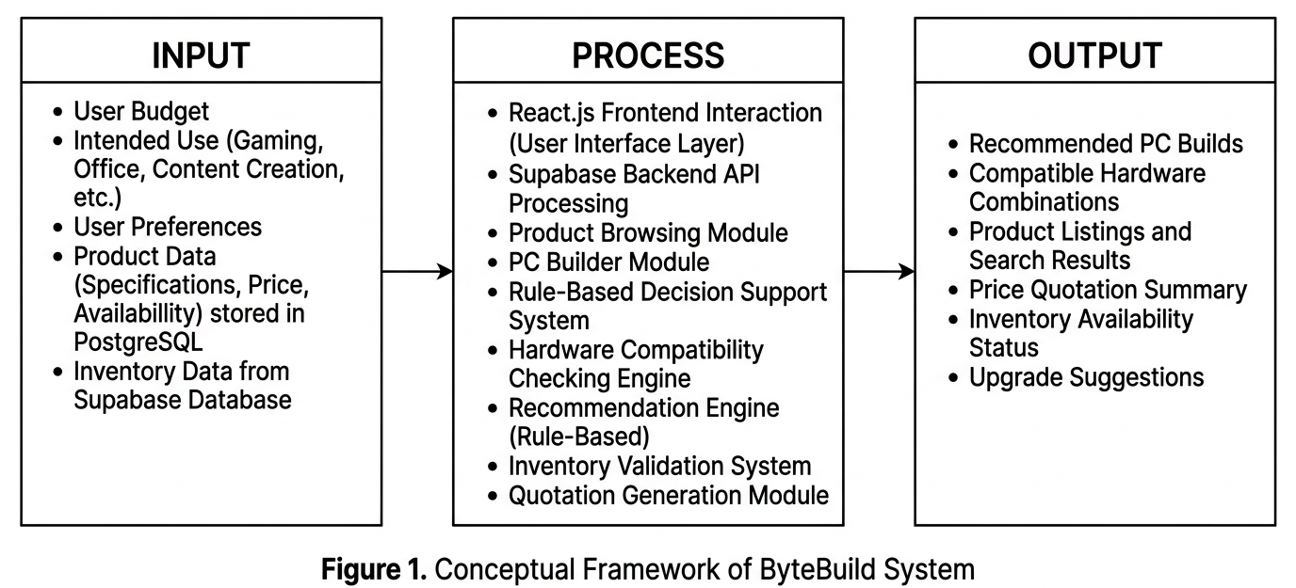

Chapter 3

TECHNICAL BACKGROUND

3.1 Technical Background
ByteBuild is a web-based e-commerce and decision support system designed to assist users in selecting and purchasing computer hardware components. It integrates modern web technologies to support product browsing, compatibility checking, recommendation generation, and inventory management.
The system uses React.js for building interactive user interfaces, Supabase for backend services including authentication and API management, and PostgreSQL for structured data storage. These technologies ensure scalability, reliability, and efficient data handling.
Existing systems such as PCPartPicker and local retailers like EasyPC and DynaQuest PC provide similar e-commerce and PC-building features. However, ByteBuild enhances these functionalities by integrating decision support features tailored for a local hardware business environment.

3.2 System Overview
The system follows a client-based architecture where users interact through a web interface. Customers can browse products or build PC configurations based on their needs.
User inputs are processed through backend services, which retrieve data from the database and apply rule-based logic for compatibility checking and recommendations.
The system outputs product suggestions, compatibility results, and inventory-based availability, helping users make informed purchasing decisions.

3.3 Software Requirements
The ByteBuild system is developed as a web-based application that utilizes modern software technologies to ensure efficient performance, scalability, and maintainability. The system’s frontend is built using React.js, a JavaScript library used for creating dynamic and component-based user interfaces. React.js is responsible for rendering key system features such as the product catalog, PC Builder interface, compatibility results, and recommendation display.
The backend services of the system are handled through Supabase, a backend-as-a-service platform that provides database management, authentication, and API functionality. Supabase simplifies backend development by allowing direct integration with the frontend while supporting real-time data handling and secure user authentication for both customers and administrators.
For data storage, the system uses PostgreSQL, a relational database management system that ensures structured, secure, and scalable storage of product information, inventory records, user accounts, and hardware specifications. PostgreSQL is suitable for complex queries required in product filtering, compatibility checking, and recommendation generation.
The system is deployed using Vercel, a cloud hosting platform optimized for frontend frameworks such as React.js. Vercel provides continuous deployment, performance optimization, and reliable hosting for web applications. Development and system integration are performed using Visual Studio Code as the primary integrated development environment, with version control managed through GitHub to ensure proper collaboration and source code management.
Overall, the software requirements of ByteBuild ensure that the system is built using modern, industry-standard tools that support efficient development, reliable performance, and seamless integration between frontend, backend, and database layers.

3.4 Hardware Requirements
The ByteBuild system is designed as a web-based application that can run on standard consumer-grade hardware. Since most of the processing is handled through cloud-based services such as Supabase and Vercel, the system does not require high-end computing specifications on the user’s device.
For client-side usage, a computer or laptop with at least an Intel Core i3 processor or its equivalent is sufficient to run the system smoothly. A minimum of 4GB RAM is required; however, 8GB RAM or higher is recommended for better performance when handling multiple browser tabs or complex product comparisons. The system can run on both integrated and dedicated graphics since it is not graphics-intensive.
A stable storage device with at least 10GB of free space is recommended to support browser caching and system usage. Any modern web browser such as Google Chrome, Mozilla Firefox, or Microsoft Edge is required to access the system. Since ByteBuild is a cloud-based application, no heavy local installation is needed, and performance mainly depends on internet connectivity rather than hardware specifications.
Overall, the hardware requirements of ByteBuild remain minimal and accessible, making the system usable on most standard desktop and laptop devices.

3.5 Network Requirements
The ByteBuild system is a web-based application that requires a stable internet connection to function properly since all core services including database operations, authentication, and data retrieval are hosted through cloud-based platforms such as Supabase and Vercel.
A minimum internet speed of at least 5 Mbps is required for basic system functionality such as browsing products and viewing hardware listings. However, a higher speed of 10 Mbps or above is recommended to ensure smoother interaction, faster data loading, and improved user experience, especially when accessing product images, PC builder features, and recommendation outputs.
The system relies on continuous internet connectivity because all user requests are processed through cloud-hosted backend services. Any interruption in connectivity may affect real-time data retrieval, including product availability updates and compatibility checking results.
The network architecture of ByteBuild follows a client-server model where the frontend (React.js) communicates with backend services hosted on Supabase through secure HTTPS requests, while the database is managed remotely using PostgreSQL cloud infrastructure.
Overall, a stable broadband internet connection is essential for the proper operation of the system, ensuring real-time synchronization between users, database, and system services.

Network Requirement Diagram:
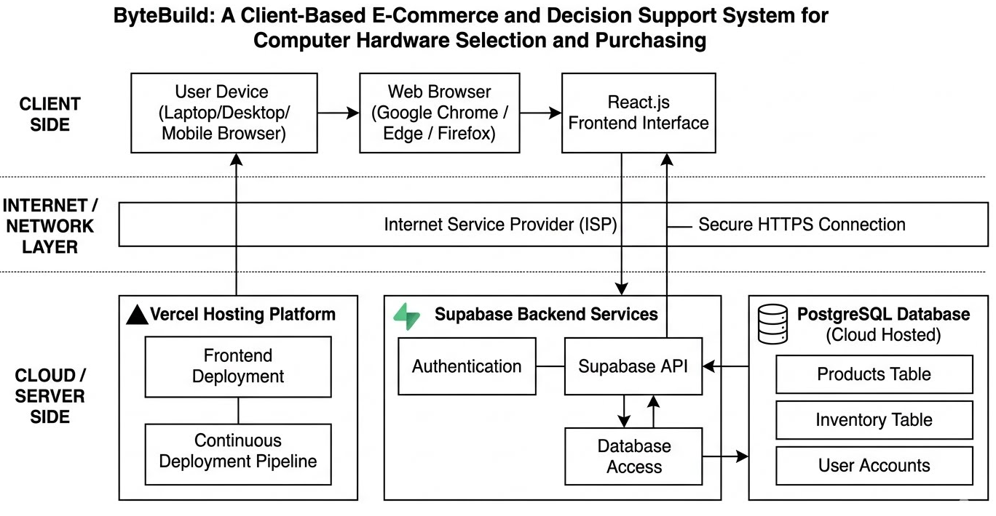

3.6 System Design
The ByteBuild system is designed to support both customer-facing and administrative functionalities through a structured web-based architecture. The system focuses on providing an intuitive user experience for customers while enabling efficient management of products, inventory, and recommendations for administrators of ByteBuild Computer Solutions. The system design is composed of interrelated modules that handle product browsing, PC building, compatibility checking, recommendation generation, and inventory management.
The overall system structure allows users to interact with the platform through a web interface built using React.js. User inputs such as budget, intended usage, and preferred components are processed by the system and validated through a rule-based decision support engine. The backend services powered by Supabase manage data transactions, while PostgreSQL serves as the central database for storing product details, user information, and inventory records.
The system design ensures that all processes are interconnected, allowing real-time data retrieval and updates between the frontend, backend, and database layers. This enables users to receive accurate product recommendations, compatibility results, and availability updates while ensuring that administrative functions remain synchronized with system operations.

3.6.1 Use Case Diagram
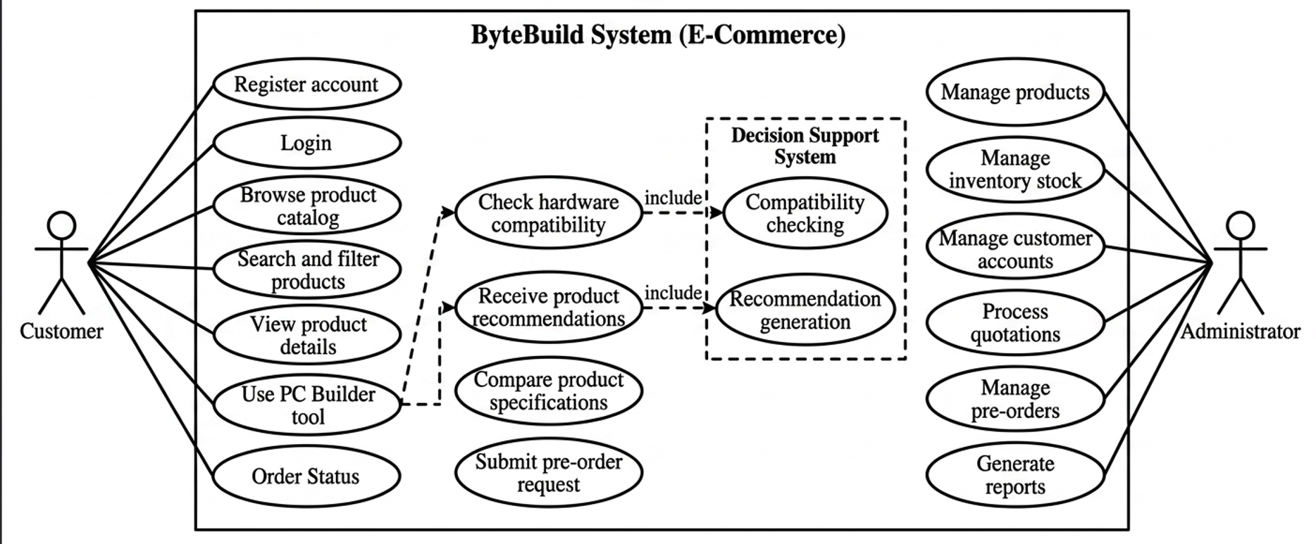

3.6.2 Data Flow Diagram (DFD)
Level 0 DFD:
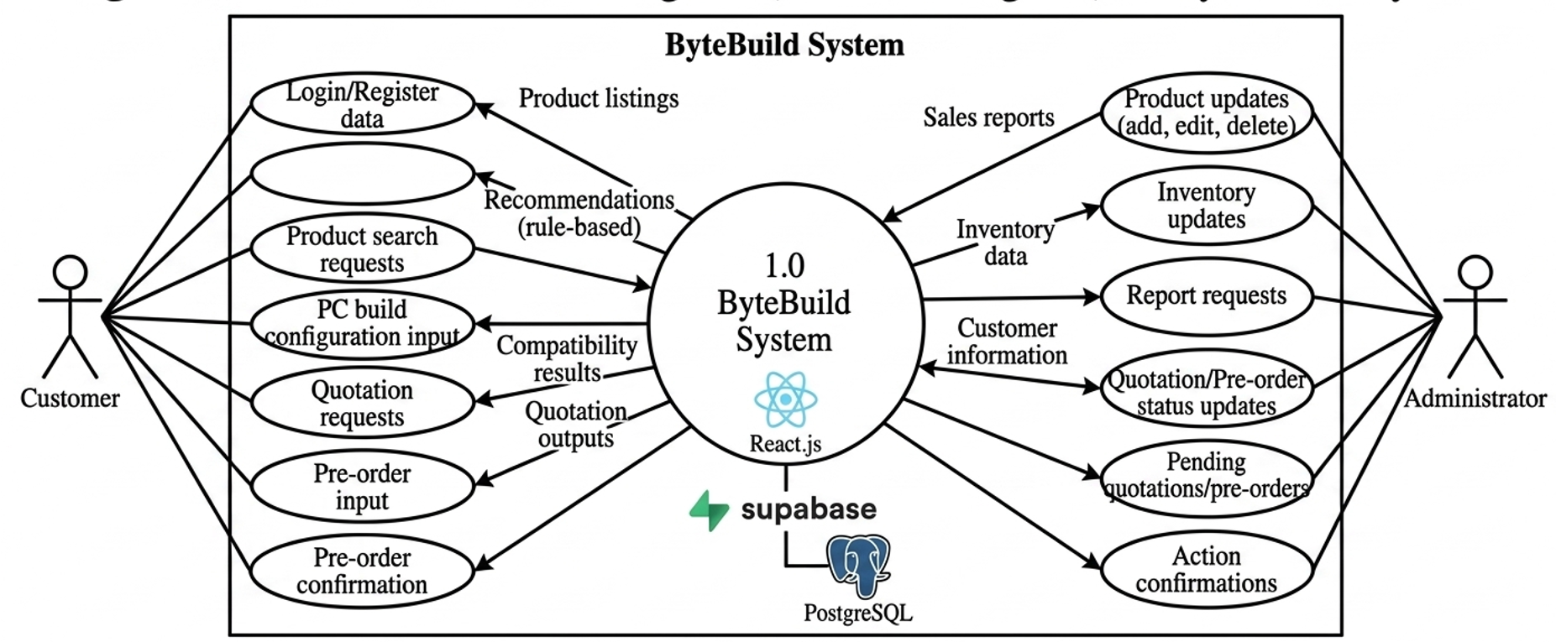

Level 1 DFD:
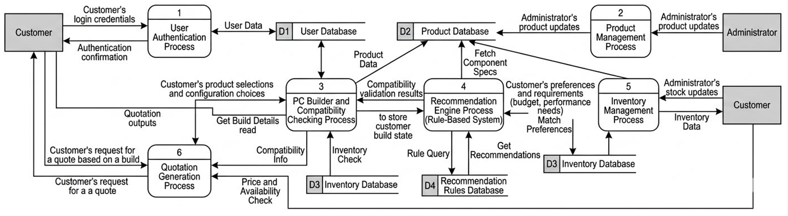

3.6.3 System Flowchart
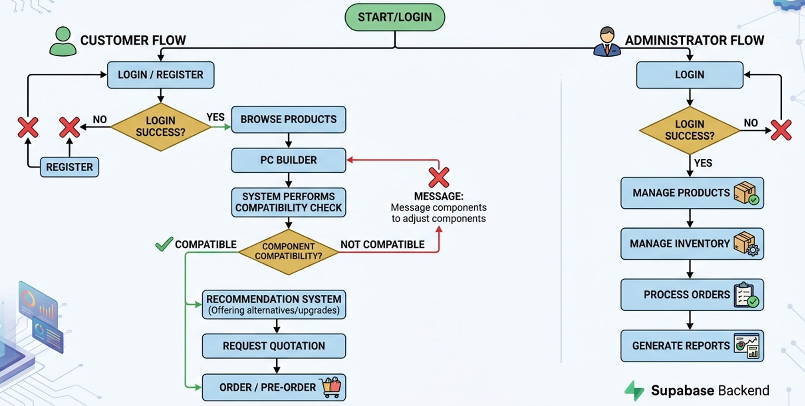

3.7 Development Tools and Technologies
The development of ByteBuild: A Client-Based E-Commerce and Decision Support System for Computer Hardware Selection and Purchasing utilizes modern web development tools and technologies to ensure a scalable, efficient, and maintainable system. The system is built using a combination of frontend, backend, database, deployment, and development tools that support the overall functionality of the platform.
The frontend of the system is developed using React.js, a JavaScript library that enables the creation of dynamic, component-based user interfaces. React.js is used to build key system modules such as the product catalog, PC Builder interface, compatibility results display, and recommendation dashboard. To support faster development and optimized build processes, Vite is used as the frontend build tool, providing a lightweight development server and hot module replacement for efficient coding workflows. Tailwind CSS is used as the styling framework to ensure responsive, consistent, and mobile-friendly user interface design across the system.
For backend services, Supabase is utilized as a Backend-as-a-Service platform that provides authentication, API generation, and database management capabilities. It allows seamless integration between the frontend and backend while supporting secure user authentication, real-time data handling, and CRUD operations. The system’s database layer is powered by PostgreSQL, a relational database management system that stores structured data such as product information, inventory records, user accounts, and hardware specifications. PostgreSQL is chosen due to its reliability, scalability, and ability to handle complex queries required for product filtering and compatibility checking.
The decision support layer of the system is implemented using a rule-based decision support system. This component is responsible for generating hardware recommendations, checking component compatibility, and evaluating system configurations based on predefined rules. This approach ensures that recommendations are transparent, explainable, and suitable for small business applications without requiring machine learning dependencies.
For authentication, Supabase Authentication is used to manage user accounts, including registration, login, session handling, and role-based access control for customers and administrators. The system is deployed using Vercel, a cloud hosting platform optimized for modern web applications, ensuring continuous deployment, performance optimization, and reliable hosting.
Development and collaboration are carried out using Visual Studio Code as the primary integrated development environment. GitHub is used for version control, source code management, and collaboration among developers, ensuring proper tracking of changes and project organization.
The combination of these development tools and technologies ensures that ByteBuild is built using industry-standard practices, providing a robust, scalable, and efficient platform for both customers and administrators.

3.8 Testing and Evaluation
The system undergoes functional testing and user acceptance testing to ensure reliability and usability. Functional testing verifies system modules, while user acceptance testing evaluates real-world usability with the client.
Feedback is used to refine system performance before deployment.

3.9 Summary of Methodology
This chapter presented the technical foundation of ByteBuild, including system architecture, requirements, design, development tools, and testing procedures.
It establishes how the system integrates frontend, backend, and database components to support decision-making and e-commerce functionality.

REFERENCES
Bridgelall, R., & Tolliver, D. (2021). Decision support systems in supply chain and inventory management. Journal of Industrial Engineering Applications, 12(3), 45–58.
Chen, L., & Zhang, Y. (2020). Rule-based recommendation systems in e-commerce platforms. International Journal of Computer Applications, 176(5), 12–20.
EasyPC. (2026). Computer hardware products and services. https://easypc.com.ph
GeeksforGeeks. (2023). Decision support system (DSS). https://www.geeksforgeeks.org/decision-support-system/
Gupta, A., & Sharma, R. (2022). E-commerce systems and consumer behavior in digital marketplaces. International Journal of Information Systems, 18(2), 77–89.
Mozilla Developer Network. (2024). React documentation. https://developer.mozilla.org/en-US/docs/Web/React
Navarro, J., & Reyes, M. (2021). Inventory management systems in small retail businesses. Asian Journal of Business Systems, 9(1), 33–41.
PCPartPicker. (2026). Custom PC building and compatibility tool. https://pcpartpicker.com
PostgreSQL Global Development Group. (2024). PostgreSQL documentation. https://www.postgresql.org/docs/

Pressman, R. S. (2020). Software engineering: A practitioner’s approach (9th ed.). McGraw-Hill Education.
Raghu, T. S., & Vinze, A. (2021). Design of decision support systems. Journal of Management Information Systems, 38(4), 102–118.
Supabase. (2026). Supabase documentation. https://supabase.com/docs
Tailwind CSS. (2024). Utility-first CSS framework documentation. https://tailwindcss.com/docs
Vercel. (2026). Frontend deployment platform documentation. https://vercel.com/docs
Wang, X., & Li, H. (2022). Online consumer purchasing behavior in e-commerce systems. Journal of Digital Commerce Research, 14(2), 91–105.

